**Resilience of a large river food web following a catastrophic pesticide spill**

**Description:** *A catastrophic spill of the potent toxin - chlorpyrifos - wiped out 15km of invertebrate life in the River Kennet, the largest tributary of the Thames, in summer 2013. This project involves tracking changes in the food web in the immediate aftermath, through to the extended period of recovery, to gauge gene-to-ecosystem responses and the resilience of the system to this major perturbation. Such large-scale and long-term data are extremely rare, and this provides a unique opportunity to work in an area of increasingly high profile in ecological research.*

**Literature Search**

1. **The River Kennet**

The Kennet is a 72-kilometre river in the south of England notable for its considerable diversity of chalk-specialised aquatic flora and fauna.

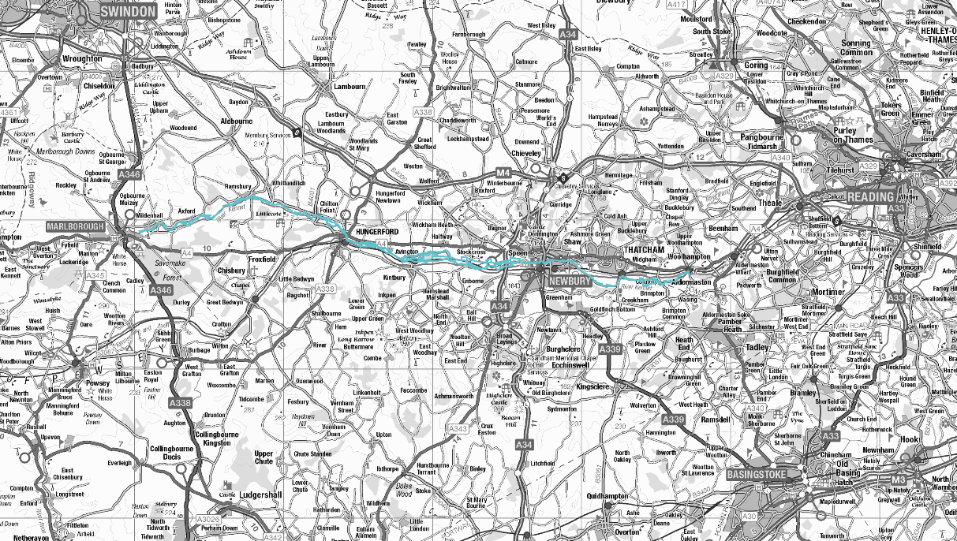

Figure 1: A terrible map of the River Kennet SSSI. Defra (2017)

1. **Organophosphate Pesticides**
   1. **History and Legislation**
   2. **Biochemistry**
   3. **Chloropyrifos**
2. **Gene-to-Ecosystem Responses**
   1. **Terrestrial**
   2. **Aquatic**
3. **Similar Case Studies**
4. **Potential Pitfalls**
5. **Methods**